**East Doncaster Baptist Church Nov. 3, 2024**

**A Legacy to Pass On**

**1 Corinthians 11. 23 -26; 10. 14 – 17.**

**Isaiah 40. 25 - 31**

I am so pleased to be here with you again.

Let me explain why, for once.

This year I have more or less retired from paid work, which takes some adjustment I have found, and in recent times several colleagues have asked me whether I’ve given much thought to my legacy.

I have to say no I haven’t. In a way that doesn’t interest me at all.

In my life at Whitley College I was certainly interested in building up a community of teachers and leaders who would carry on after me. But as for setting directions and a kind of dynasty, or heritage, no.

Except, that when I come to a place like this, I do have a sense of being part of something that is going forward, moving beyond my time.

I guess there are many of us who wonder what the world is coming to. How did it get the way it is, and what will become of it?

This week in the USA that is a huge question, and sometimes I wish they would just keep their power games to themselves and leave the rest of us alone, but there’s no chance of that.

It is a reasonable thing to think about, at home, in the family, at church, and in our community. What will we leave behind us?

A Jewish Rabbi named Harold Kushner wrote a wonderful book called *When Bad Things Happen to Good People.* It became a classic. Soon after he wrote another equally helpful book: *When All You’ve Ever Wanted Isn’t Enough:* subtitled, ‘the search for a life that matters.’

In a chapter entitled ‘Was there something I was supposed to do with my life?’, Kushner recounts the story of a deeply troubled man who asked to meet with him one evening: The man explained that a work colleague had died suddenly, just two weeks earlier. The colleague had already been replaced, and his wife and family had moved inter-state already.

The man reflected: ‘It’s as if he never existed. It’s like a rock falling into a pool of water. For a few seconds, it makes ripples in the water, and then the water is the same as it was before, but the rock isn’t there anymore. Rabbi, I’ve hardly slept at all since then. I can’t stop thinking that it could happen to me, that one day it *will* happen to me, and a few days later I will be forgotten as if I had never lived. Shouldn’t a man’s life be more than that?’ (p.20)

We might change that to: Shouldn’t any person’s life be more than that?

And with the reading from Isaiah we might wonder what in all this life is permanent, or worthwhile.

Rabbi Kushner wrote this book soon after the death of his own father, and at the time he turned 50 years of age. Kushner explores themes from the biblical book of Ecclesiastes, which asks whether indeed all of life is ‘vanity’ or eventually without consequence.

In the Bible there are some classic stories of people who took hold of this question in very different ways.

A man called Abram somehow became convinced that he was called by God, a God he did not know in any specific way at all, to leave his home and travel, not even knowing where to, and in all that God would make him the father of a great nation. Abraham would have a destiny—except that by the time he was ninety nine years old and as one translation puts it he was ‘practically dead’, his wife conceives and they have a son.

But soon after, in the story you will find in Genesis 21, Abraham planted a tree. It was a very slow growing tree, a tamarisk: and with that he declares that this is his position in life. The promise or covenant to which he has given his life, not one bit of it easy, and still he has no country of his own, just a wanderer, rich, yes, in sheep and cattle, —but in terms of his life’s meaning it is as fragile as a child’s health, not to mention his own very advanced years.

A hundred years old, and Abraham planted a tree.

Many hundreds of years later the people known as Israel were about to be devasted, as yet another foreign king laid siege to their territory, a great army ready to destroy the capital, Jerusalem, and carry all the leaders, the king, public officials, priests and business leaders, take them all away into Babylon, as prisoners and slaves, and leave the ordinary folk to fend for themselves on lands that had already been burned—and all this happened while a prophet called Jeremiah had warned them about trusting in foreign powers, rather than in their invisible and seemingly powerless God.

Well, they took no notice of Jeremiah, but his warning proved to be spot on.

And just then, according to Jeremiah 32, as he too expected to be taken away into exile, Jeremiah bought a block of land.

Who buys a block of land when the whole system of property is about to be smashed, and your own life is likely to be terminated unceremoniously?

Yet, as that man said to his Rabbi: shouldn’t a person’s life be worth something more?

Isn’t there something more to it all?

I imagine that some of you will have been to Barcelona to see this astonishing basilica called the Sagrada Familia.

(Picture of the building)

It was begun in 1882, designed by the amazing Antoni Gaudi. It was barely begun when he died in 1926, but the work has continued, and they hope to have it completed for his centenary in 2026.

Gaudi had a deep passion for people who didn’t like church, especially those who loved the land, who worshipped in nature, as he saw it, and for that reason the great pillars of this building are made to look like trees and much of the decoration depicts plants and fruits and birds.

(picture of inside)

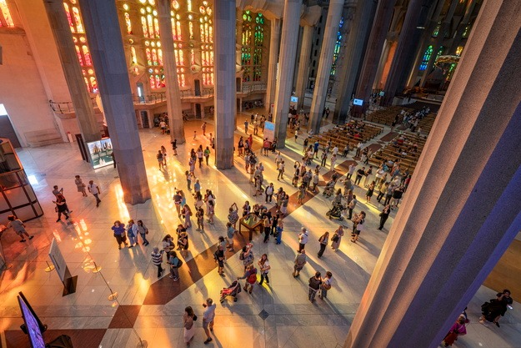

Gaudi left something that would go on after him, and which will offer a vision of life for a very long time into the future.

And here today, in our own funny little way, we are engaging too in something of this nature.

We will recount a story about Jesus, who on the night before he died took some very natural things, bread and wine, and more or less adapted an ancient tradition, the Passover, creating another memory to go with it, something that we even today pass on.

I just used the word ‘tradition’. It’s a difficult word for most Australians, and for most Baptists, and we have a double dose of this difficulty.

As the musical *Fiddler on the Roof* identifies, tradition is something you take with you, whether you choose it or not—and even those of us who want to avoid traditions find we not only follow some, we even create new ones!

A wonderful scholar named Jaroslav Pelikan wrote these incredibly helpful words:

Jaroslav Pelikan:

Tradition is the living faith of the dead;

Traditionalism is the dead faith of the living.

If we are stuck on traditions, we may be operating out of a dead faith or practice.

But we can receive and gain deep advantage from the living faith of the dead. I call this *traditioning*. Using and living into traditions that give something, the living faith of the dead.

Jesus gave us this tradition. He himself was using and adapting a tradition: what he was saying is that what was happening right then was a way of participating in the meaning of those ancient stories: it was not about dreaming of the past: it was for them a way of striking out for a land of promise; it was a way of planting a tree, or buying a block of land, in the face of disasters and strife.

Here we light a candle in the wind, and we say: this is life. This is the way of the creator of all things. This too is to be passed on. This will carry us on.

There is a temptation for us to imagine that tradition is about the past, and some of us try to live in the past, or re-create what we imagine it was like.

Little children, you may have noticed, tend to have a clear -eyed conviction about the future. They are growing, learning, becoming. They know they will go to kinder soon, or school, and so on.

But in reality all we have is the present.

Actually none of us knows how long we are here for and what will become of all we have done, collected, built, insured—no, actually all we have is the present: to live, now.

But we can live now *for the sake of passing on*.

People use that expressing, passing on, to mean dying.

But I am not talking about dying. I am talking about living to pass on all that is meaningful and life-giving.

This, you see, is what Jesus was doing.

Paul the Apostle wrote in 1 Corinthians that he passed on a tradition.

There he is using an interesting word which Jesus also used, on the cross, according to John 19. 30: we read that he handed on his Spirit. He didn’t give up the ghost, as we might translate it: he handed over, or handed on his very life.

There is a traditioning, you see: where we pass on the story, we plant a tree or start something, build something, buy something, that will be far more than we will ever see.

That’s what those great cathedrals of Europe and the great temples in Asia say to us: here is something started by people who did not want to see the finish of it: they wanted something more than that—a traditioning, a passing on, a legacy that will live, others will pick it up and revise, revive, restore, reclaim—and life will go on.

This is why I love coming here. Not because of what happened forty years ago, but because of what will become of it all: what will pass on, what will grow yet.

Jesus passed on a tradition. Paul received it and passed it on.

We too have received and are passing on.

And God, the living Spirit of all life, past and present and future, God is the great traditioner, who will make something of what we pass on too.

May it be so. Amen.